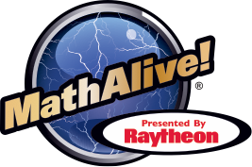
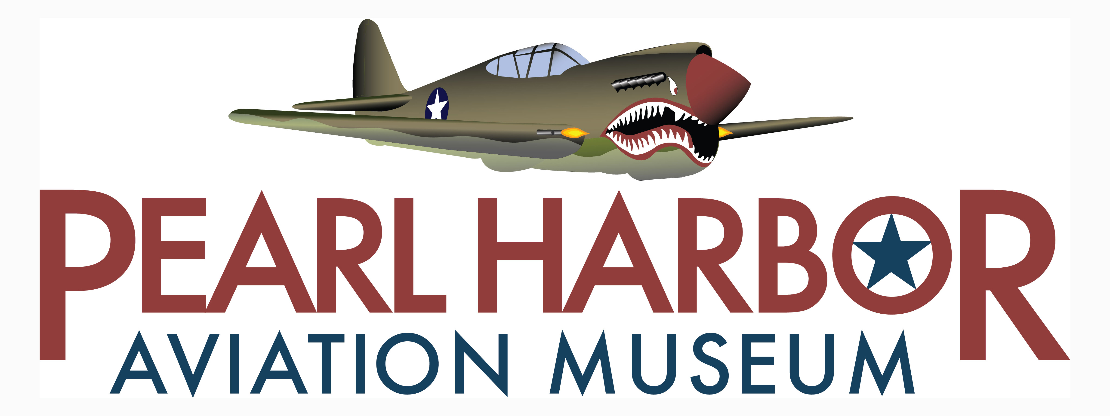
RAYTHEON BRINGS MathAlive! EXHIBITION TO PEARL HARBOR AVIATION MUSEUM

HONOLULU, Hawaii (October 9, 2018) – Challenge others in a downhill snowboard race, edit your own animated movie, take a 360 degree selfie, create an original score as a music producer, and control Curiosity, NASA’s latest Mars rover – all at Pearl Harbor Aviation Museum!

MathAlive!, a highly interactive traveling exhibition that has drawn record-breaking crowds across the U.S., opens Thursday, November 15, 2018 at Pearl Harbor Aviation Museum. Presented nationally by Raytheon Company (NYSE: RTN), MathAlive! helps kids have fun with math by showing them its connection to – and influence on – many of the things they love most: music, sports, movies, games, fashion and more.

MathAlive! will be presented in the newly donated Raytheon Pavilion, a temporary building specifically constructed on the grounds of the Museum to house the block buster exhibition.

“We’re thrilled to have been selected by Raytheon to host the MathAlive! exhibit. The experiences and exhibit space will provide an incredible learning environment for visitors,” said Elissa Lines, Executive Director of Pearl Harbor Aviation Museum. “Inspiring our youth is an important part of our mission. This exhibit offers another way for us to spark youth imagination and create a lifelong love of math and science.”

The 4,000-square-foot exhibition brings to life the various types of mathematics at work in the world around us. Throughout the experiences, professionals, celebrities and visionaries explain how they use math in their respective fields.

MathAlive! is designed to appeal to all ages and levels of math ability, but with particular relevance to kids in grades 3-8. The exhibit was created in direct response to the larger need to improve math proficiency among students, and inspire kids to explore and pursue STEM (science, technology, engineering and math) careers. For teachers, the exhibition serves as an entertaining and relevant exploration lab. Each interactive station presents different types and levels of math, so students at different grade levels will find the entire experience applicable and supportive to what they are learning in the classroom.

“Raytheon understands the importance of preparing our youth to succeed in our ever-changing technological world,” said Raytheon Chairman Thomas A. Kennedy. “By engaging students and getting them excited about math and science through exhibits like MathAlive!, we’re investing in the next generation of STEM-ready professionals.”

MathAlive! will be presented at Pearl Harbor Aviation Museum through August 18, 2019. Admission to the exhibit is free with the price of Museum admission. The exhibition is free to all active duty military members and their families. For more information, or to schedule a school visit, call the Museum at (808) 441-1000 or visit www.pearlharboraviationmuseum.org

About the Pearl Harbor Aviation Museum
Pearl Harbor Aviation Museum is located on Historic Ford Island, where bombs fell during the attack on Pearl Harbor, December 7, 1941. Visitors to the Museum can see remnants from that day of infamy, including the 158-foot tall, red and white iconic Ford Island Control Tower, Hangars 37 and 79, and bullet holes in Hangar 79. Through its preservation and restoration of World War II fighter planes and accompanying artifacts in the Museum’s historic hangars, Pearl Harbor Aviation Museum shares the story of the vital role aviation played in the winning of World War II, and its continuing role in maintaining America’s freedom. Pearl Harbor Aviation Museum is a 501(c) (3) non-profit organization. Its mission is to steward America’s first aviation battlefield of World War II sharing the artifacts, personal stories, the impact and response to the December 7, 1941 attack and the Pacific region battles that followed, honoring those who have defended our freedom so we might educate and inspire future generations.

About Raytheon
Raytheon Company, with 2017 sales of $25 billion and 64,000 employees worldwide, is a technology and innovation leader specializing in defense, civil government and cybersecurity solutions. With a history of innovation spanning 96 years, Raytheon provides state-of-the-art electronics, mission systems integration, C51 products and services, sensing, effects, and mission support for customers in more than 80 countries. Raytheon is headquartered in Waltham, Massachusetts. www.raytheon.com

# # #

